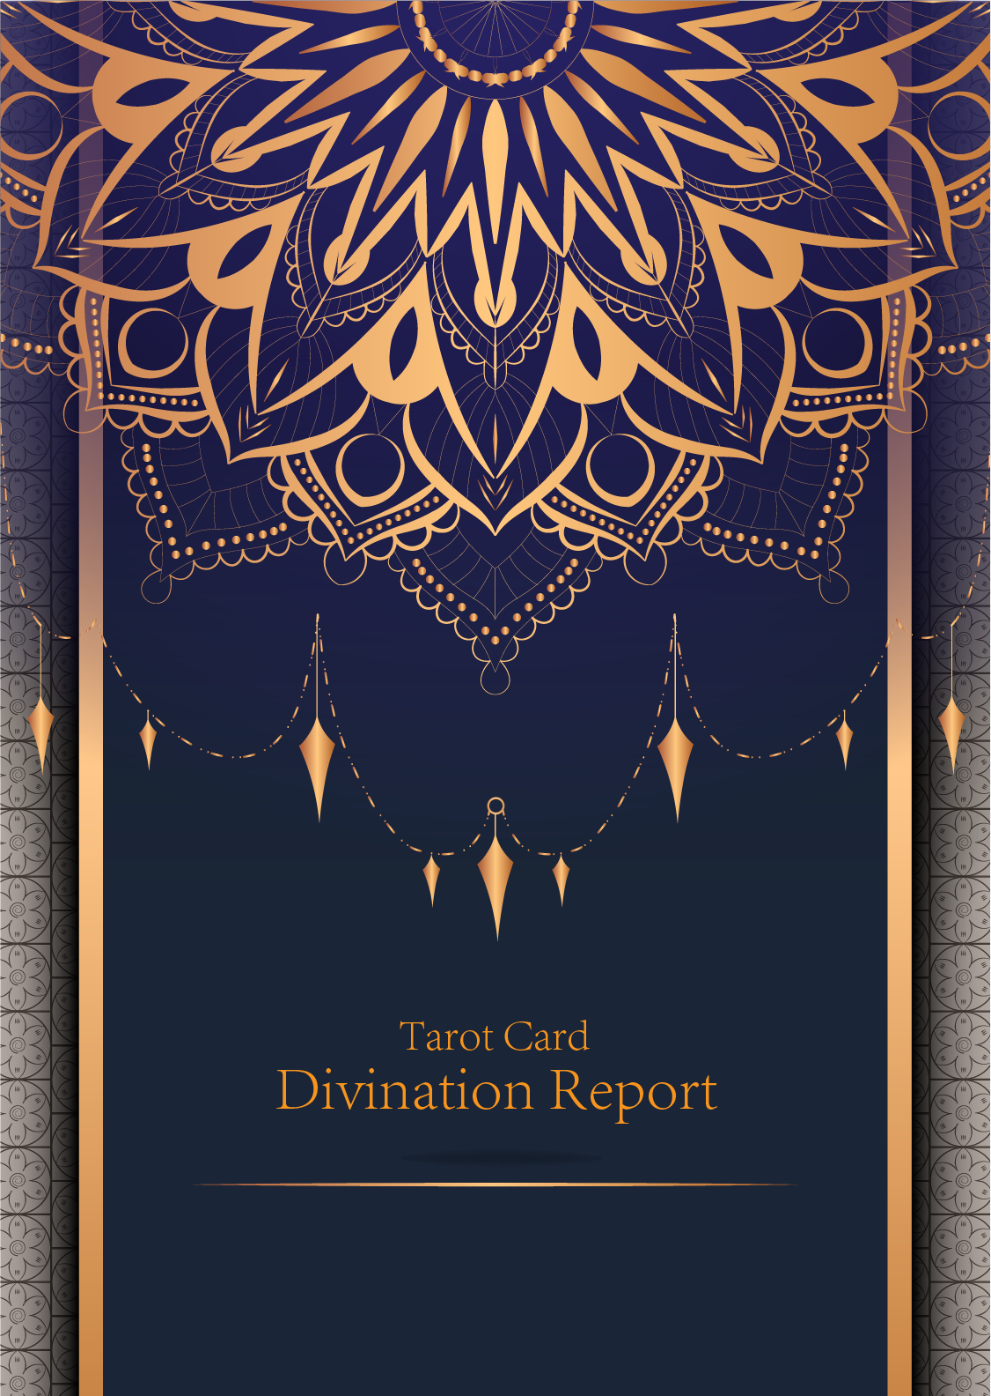

|  |
| --- |
| February 23, 2024 |

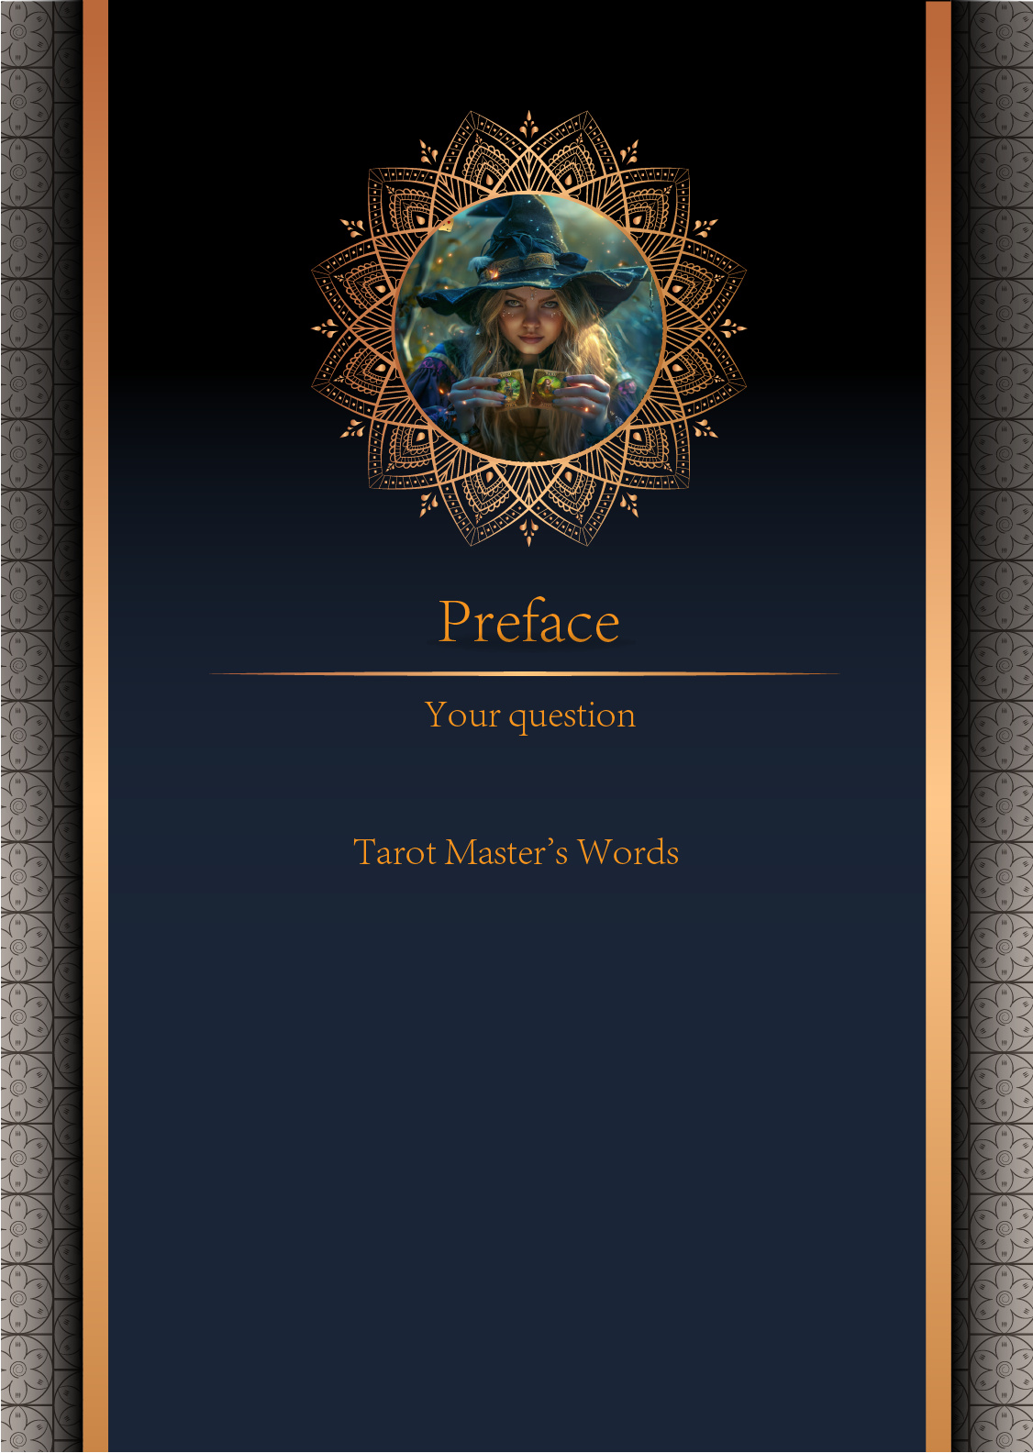

|  |
| --- |
| 我什么时候能结婚 |

|  |
| --- |
| Before we begin the interpretation, I would like to explain some important points to you. Tarot cards are not tools for predicting the future, but rather tools for guiding us to delve deeper into various situations in life. Therefore, when receiving the reading, please maintain an open mindset and trust your intuition. Our goal is to provide you with inspiration and guidance through the guidance of the tarot cards, helping you better deal with challenges and decisions in life. Alright, you can start reading now! |

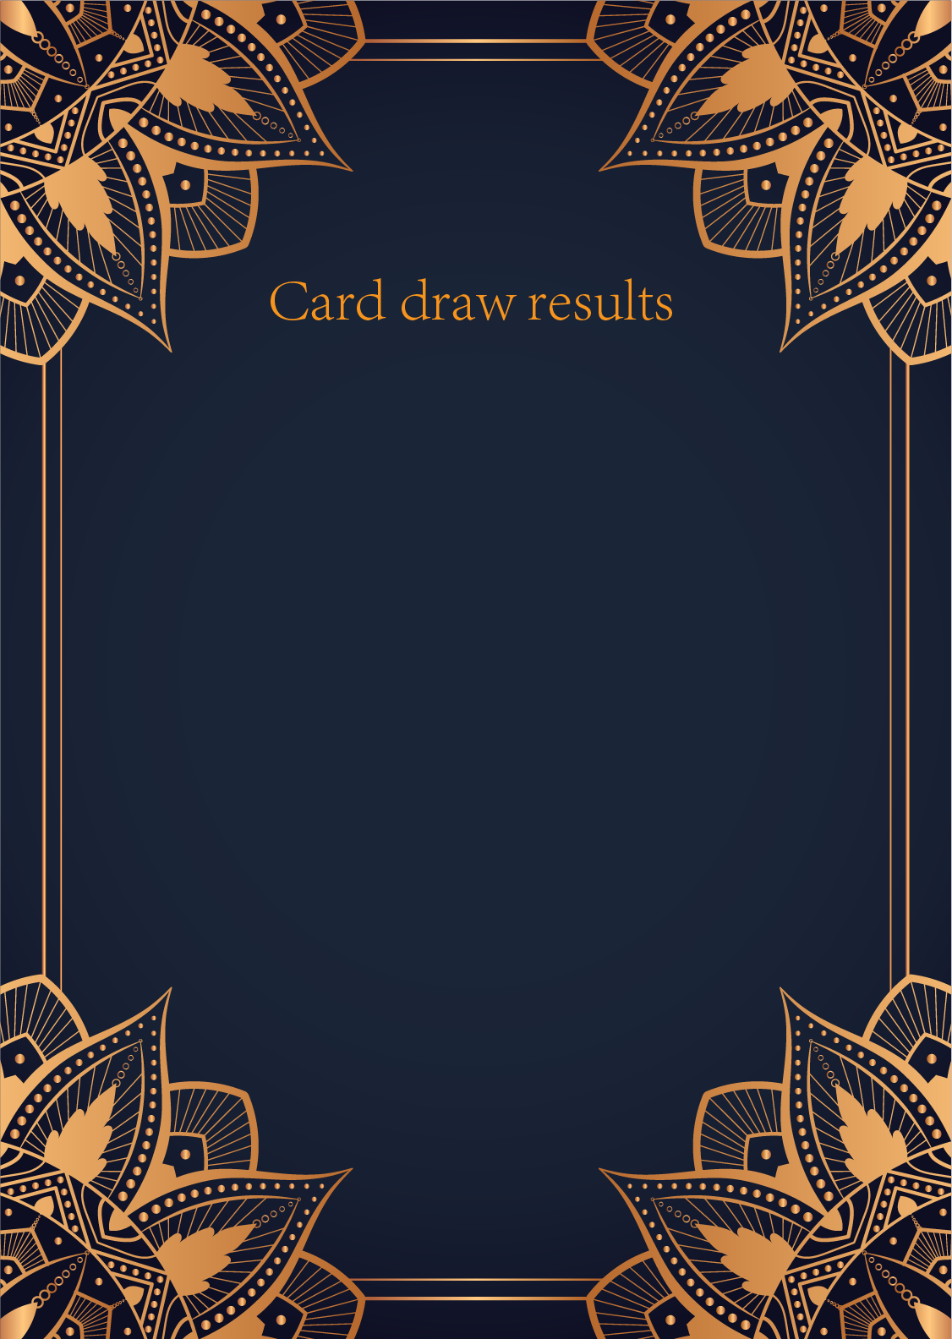

|  |
| --- |
| CardⅠ The Sun |
|  |
| The Sun card presents an feeling of optimism and fulfillment. This card represents the dawn which follows the darkest of nights. The Sun is the source of all the life on our planet, and it represents life energy itself. There is a child depicted in the card, playing joyfully in the foreground. A symbol of our innocence, it represents the happiness that occurs when you are in alignment with your true self. The child is naked, meaning that he has absolutely nothing to hide. The card also depicts the childhood innocence and absolute purity. This is particularly emphasized through the white horse upon which the child is riding. The horse here is also a symbol of strength and nobility. |

|  |
| --- |
| CardⅡ The Moon |
|  |
| When we encounter the Moon, we see a path that leads off into the distance. On either side of the path stand a wolf and a dog, representing our animalistic nature - one is civilized, and the other wild and feral. There is a crawfish that is crawling out of the pond from which the path stems from. In the distance, we can see two towers flanking the central path, once again alluding to the doubles visible in this card. Everything in this card seems to echo the other, as if to allude to two possibilities. When we walk down the path, we walk the fine line between conscious and unconscious, between the tamed side of civilization of the dog, and the forces of nature represented by the wolf. |

|  |
| --- |
| CardⅢ The Star |
|  |
| The Star card shows a woman kneeling at the edge of a small pond. She is holding two containers of water. One container pours the water out to the dry land, as if to to nourish it and ensure its fertility. The lush green land around her seems to say that it is working. One foot is inside the water which shows the spiritual abilities and inner strength of the woman. The other foot on the ground shows her practical abilities and strengths. Behind her, there is a large central star surrounded by seven small stars which represent the chakras. There is bird standing at a tree branch which represents the holy ibis of thought. The Star's astrological correspondent is Aquarius. |

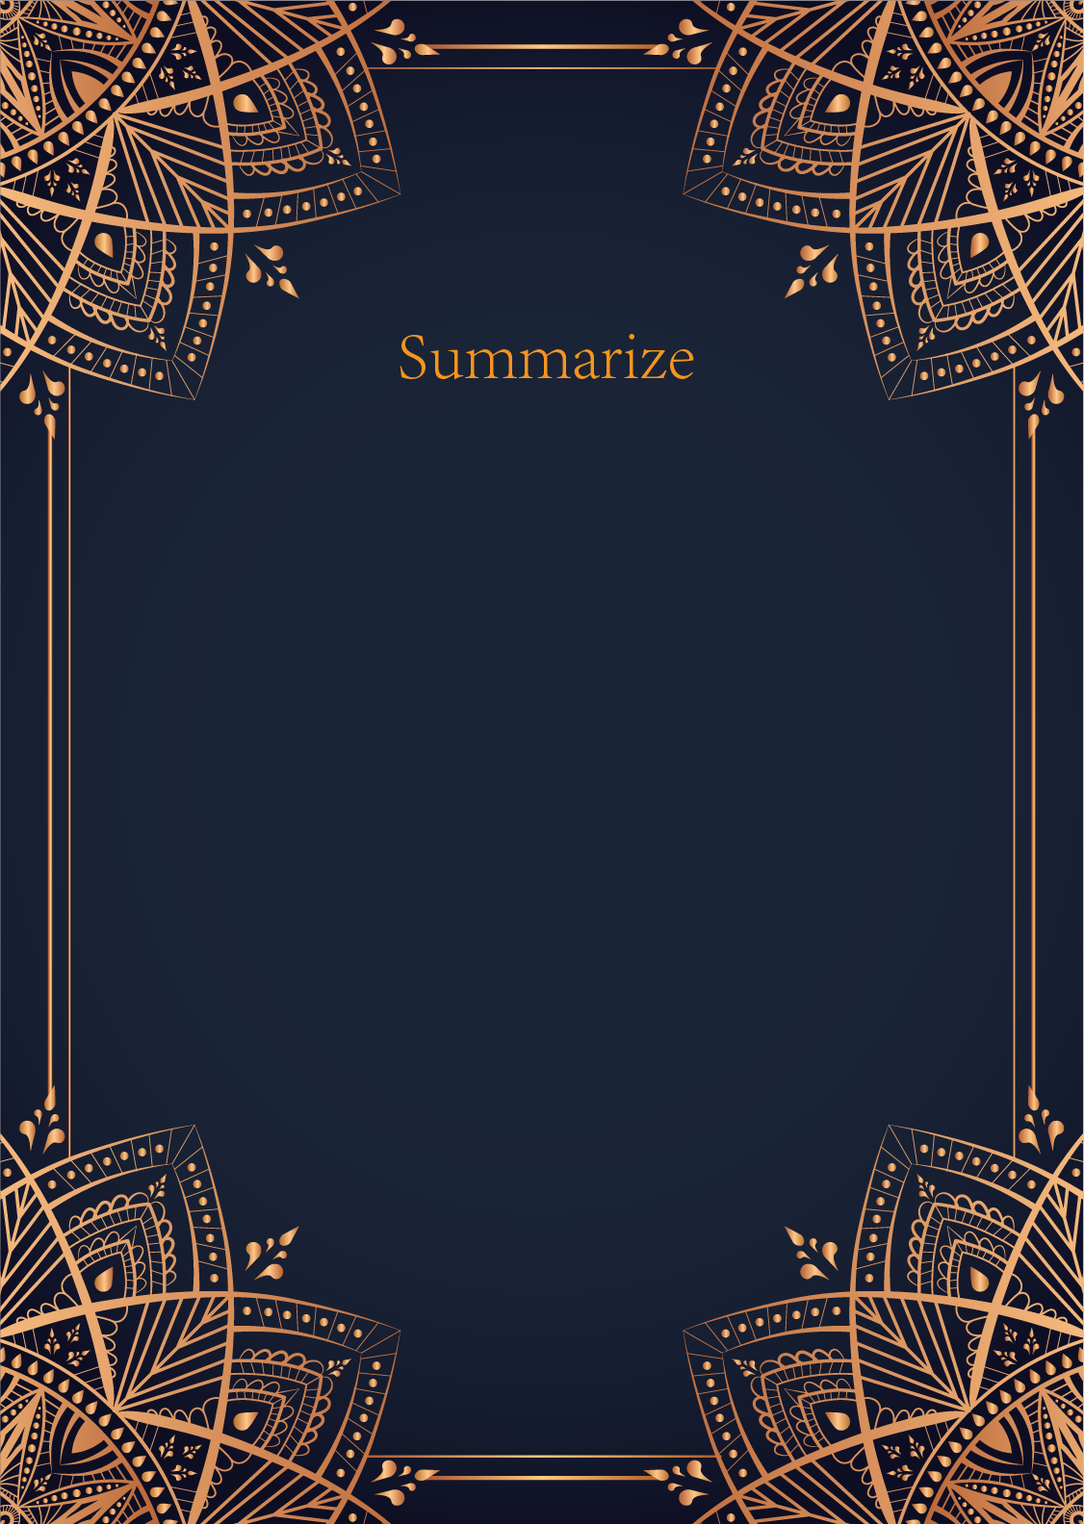

|  |
| --- |
| Ah, my dear seeker of knowledge, the cards have revealed to me a message of great significance regarding your inquiry about marriage. The Sun, the Moon, and the Star have spoken to me in the language of the cosmos, each offering their unique insights into your future union.  The Sun, a symbol of joy, success, and vitality, shines its bright light upon your path to matrimony. It indicates that a period of warmth and happiness is approaching in your love life. This card suggests that your marriage will take place during a time of abundance and fulfillment, when you and your partner will bask in the glow of mutual love and harmony.  The Moon, with its mystical and intuitive energy, speaks to the emotional depths of your connection with your future spouse. This card symbolizes a deep soul connection and a sense of mystery surrounding your union. It suggests that your marriage will be a journey of self-discovery and emotional growth, where you and your partner will explore the hidden realms of your hearts and minds together.  And finally, the Star, a beacon of hope and inspiration, guides you towards a union that is destined to be a source of light and guidance in your life. This card represents a sense of divine purpose and alignment in your marriage, indicating that you and your partner are fated to come together in a union that will illuminate your path and bring you closer to your true selves.  In essence, the cards indicate that your marriage will be a celebration of love, harmony, and spiritual connection. It is a union that is destined to bring you joy, emotional depth, and a sense of purpose and meaning in your life. Trust in the wisdom of the cards, dear seeker, and know that the stars have aligned in your favor for a beautiful and fulfilling marriage in the future. Embrace the journey with an open heart and a spirit of adventure, for your path to matrimony is one of magic and wonder. |

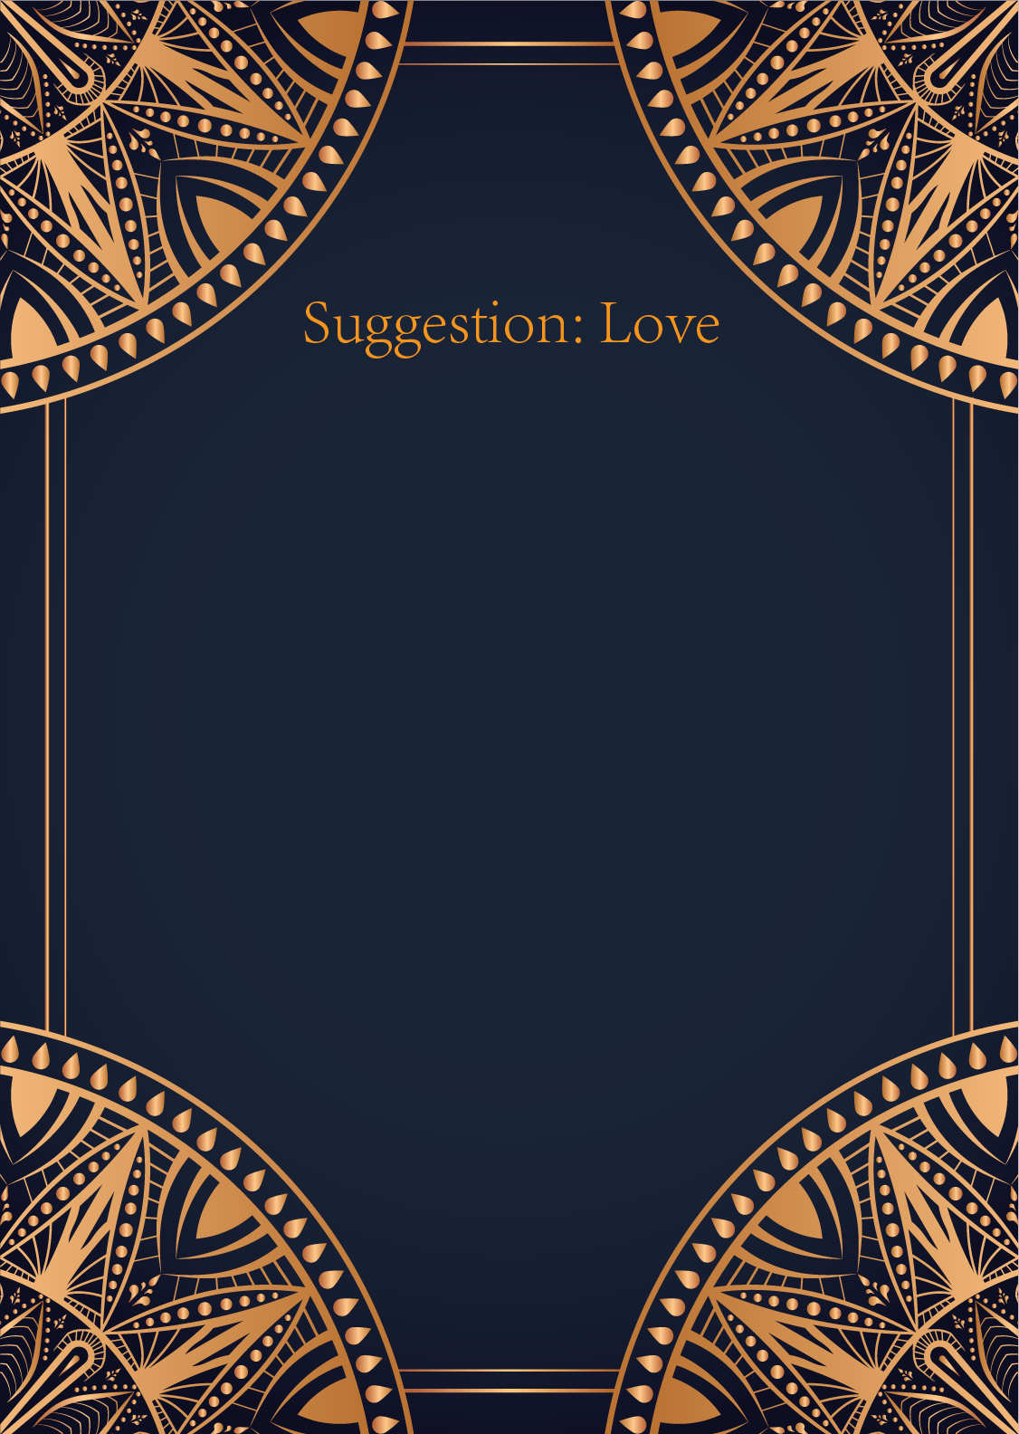

|  |
| --- |
| Ah, the Sun, the Moon, and the Star. An intriguing combination of cards that speak of love, light, intuition, and guidance. In matters of the heart, these cards suggest a journey of self-discovery, emotional fulfillment, and divine connection.  The Sun radiates warmth, joy, and positivity, urging you to embrace love with an open heart and a bright outlook. This card signifies happiness, success, and a deep connection with your romantic partner. It encourages you to bask in the light of love and let your true feelings shine through.  The Moon, on the other hand, represents intuition, dreams, and subconscious desires. It reminds you to listen to your inner voice, trust your instincts, and explore the deeper layers of your emotions. This card suggests that there may be hidden truths or unresolved issues in your relationship that need to be addressed with sensitivity and compassion.  And finally, the Star symbolizes hope, inspiration, and spiritual growth. It serves as a guiding light in times of darkness, offering you reassurance that love will prevail and your dreams will be realized. This card encourages you to believe in the power of love and to have faith in the future of your relationship.  In essence, these cards advise you to approach your love life with optimism, authenticity, and a willingness to explore the depths of your emotions. Trust in the journey of love, follow your intuition, and keep your sights set on a bright and hopeful future. Remember, love is a cosmic force that connects us all, and with the Sun, the Moon, and the Star on your side, you are destined for a love that shines brightly in the night sky.  May your heart be filled with love and light on your romantic journey, dear seeker. Embrace the magic of the Sun, the Moon, and the Star, and let their wisdom guide you to a deeper understanding of love and relationships. Blessed be. 🌞🌜⭐ |

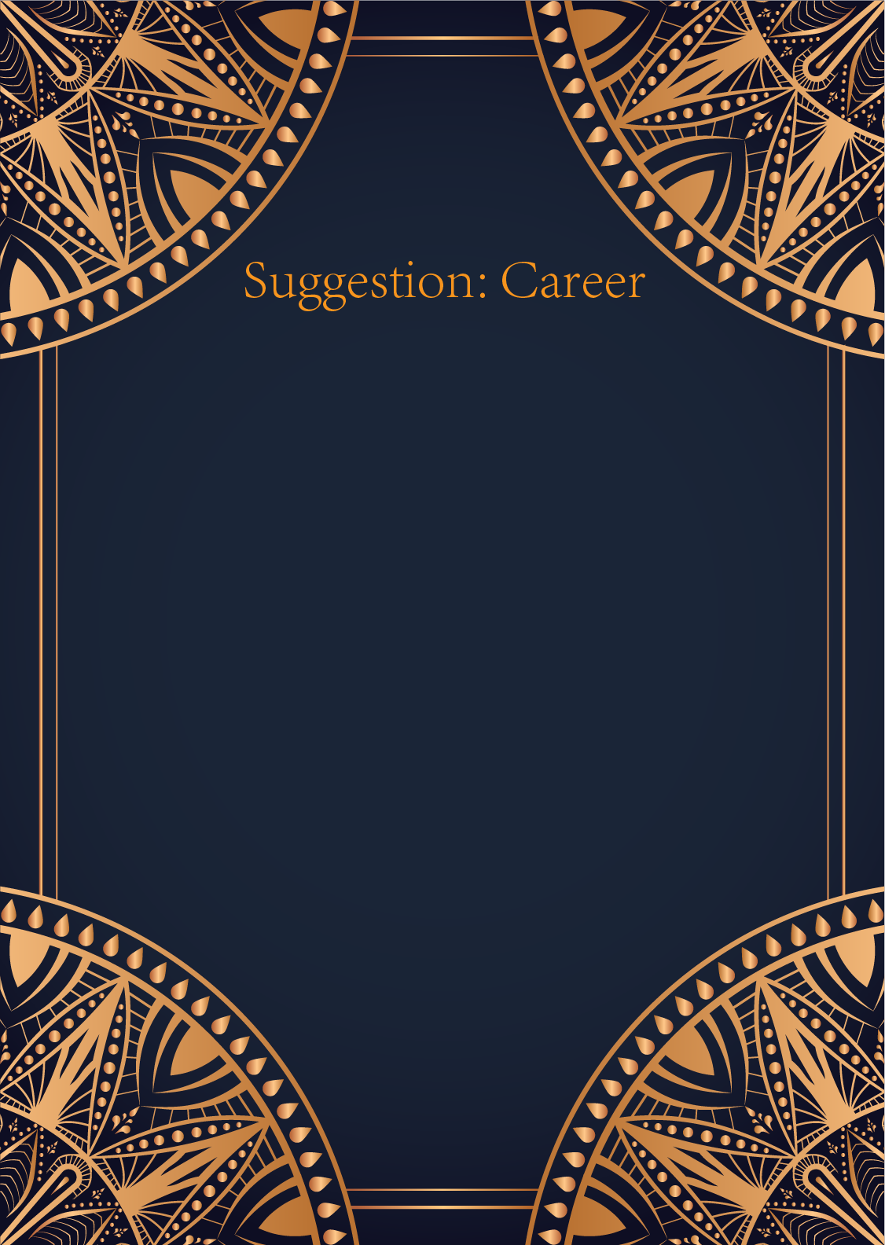

|  |
| --- |
| Ah, the Sun, the Moon, and the Star, a powerful trio indeed. These cards represent success, intuition, and hope shining brightly in your professional life. The Sun signifies achievement, recognition, and abundance in your career path. It urges you to step into the spotlight, embrace your talents, and allow your creativity to flourish. Remember to bask in the warmth of your achievements and strive for even greater success.  The Moon speaks to your intuition and inner guidance. It encourages you to trust your instincts, listen to your inner voice, and explore the hidden depths of your potential. Embrace the mystery and uncertainty of your career journey, for it is through navigating the shadows that you will discover new opportunities and insights. Stay connected to your emotions and intuition as you navigate the ebbs and flows of your professional life.  And finally, the Star whispers of hope, inspiration, and fulfillment. It is a beacon of light guiding you towards your true calling and purpose. Allow yourself to dream big, set ambitious goals, and believe in the limitless possibilities that await you. Stay true to your authentic self and let your unique light shine brightly in the darkest of times.  In conclusion, these cards urge you to embrace your success, trust your intuition, and believe in the infinite potential that lies within you. Stay true to your path, follow your heart, and let your inner light illuminate the way forward in your career journey. Remember, the universe is conspiring in your favor, guiding you towards a fulfilling and prosperous professional life. Trust in the journey, dear seeker, and embrace the magic that awaits you. |

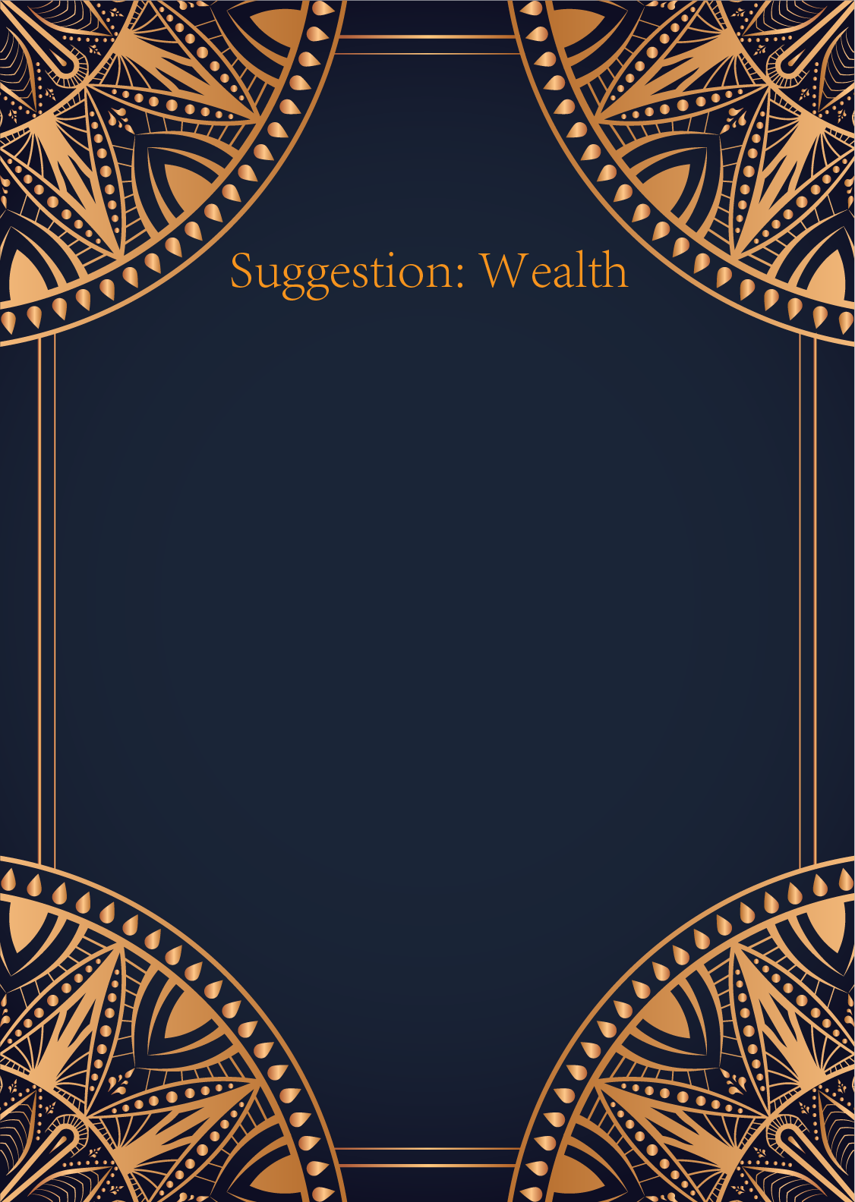

|  |
| --- |
| Ah, the Sun, the Moon, and the Star - a powerful trio of cards that shine brightly in the realm of finances. Let us delve into the mystical energies they hold and unveil the guidance they offer to illuminate your path to prosperity.  The Sun, with its radiant rays of success and abundance, urges you to embrace optimism and confidence in your financial endeavors. It signifies a time of growth, achievement, and financial stability. This card encourages you to believe in your abilities, take bold steps towards your goals, and trust that the universe will support your journey towards financial fulfillment.  The Moon, cloaked in mystery and intuition, reminds you to trust your instincts and delve deep into the realms of your subconscious when it comes to your finances. This card asks you to pay attention to your emotions and hidden desires around money, as they may hold valuable insights into your financial situation. Embrace the ebb and flow of the financial tide with grace and adaptability, knowing that challenges are simply opportunities for growth and transformation.  And finally, the Star, a beacon of hope and inspiration, shines a light on your financial dreams and aspirations. This card encourages you to have faith in the abundance of the universe and to set your sights high when it comes to your financial goals. Trust in the power of manifestation and visualize your financial success with clarity and intention. The Star reminds you that you are destined for greatness in your financial pursuits and that your dreams are within reach if you believe in yourself.  In conclusion, dear seeker, the cards speak of a journey towards financial prosperity guided by optimism, intuition, and unwavering faith in the abundance of the universe. Embrace the energy of the Sun, trust the guidance of the Moon, and reach for the stars with the confidence and belief of the Star. May your financial path be illuminated with blessings and success as you navigate the mystical realm of wealth and abundance. |

